SAFETY DATA SHEET
according to 1907/2006/EC, Article 31

DE-ICER SPRAY

SECTION 1: Identification of the substance/mixture and of the company/undertaking
1.1. Product identifier
Product name DE-ICER SPRAY
1.3. Details of the supplier of the safety data sheet
Company Active Brand Concepts Ltd
Address The Forge
Crewe Hall Farm
Crewe
CW1 5UE
Web www.homecareproducts.co.uk
Telephone 0844 335 0816
Fax 0844 335 0854
Email sales@active-brand-concepts.com
Email address of the sales@active-brand-concepts.com
competent person
Local Supplier
Company Bulk Products Ltd
Address Unit 2 Marshfield Bank
Middlewich Road
Crewe
Cheshire
CW2 8UY
United Kingdom
Web www.homecareproducts.co.uk
Telephone 0844 335 0816
Fax 0844 335 0854
Email sales@active-brand-concepts.com
Email address of the sales@active-brand-concepts.com
competent person
1.4. Emergency telephone number
Emergency telephone number 08443350816
Company James Sharpe
8.30 - 5
SECTION 2: Hazards identification
2.1. Classification of the substance or mixture
2.1.1. Classification - Xn; R20/21/22-68/20/21/22 R10
1999/45/ЕC Symbols: Xn: Harmful.

Revision
Revision date

Page 1/6

1

Main hazards
Flammable. Harmful by inhalation, in contact with skin and if swallowed. Harmful: possible risk of
irreversible effects through inhalation, in contact with skin and if swallowed.

Copyright © 2015 ChemSoft Limited. All rights reserved.

Powered by

Print date 2015-11-02

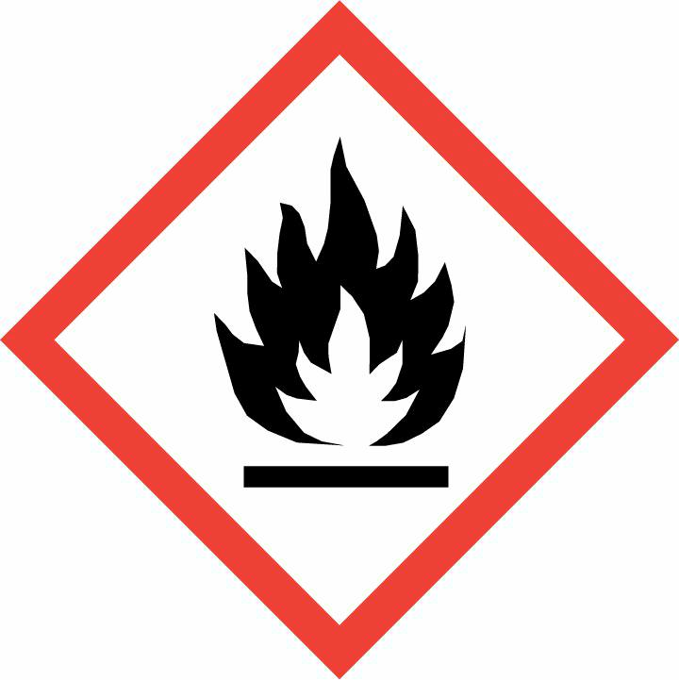
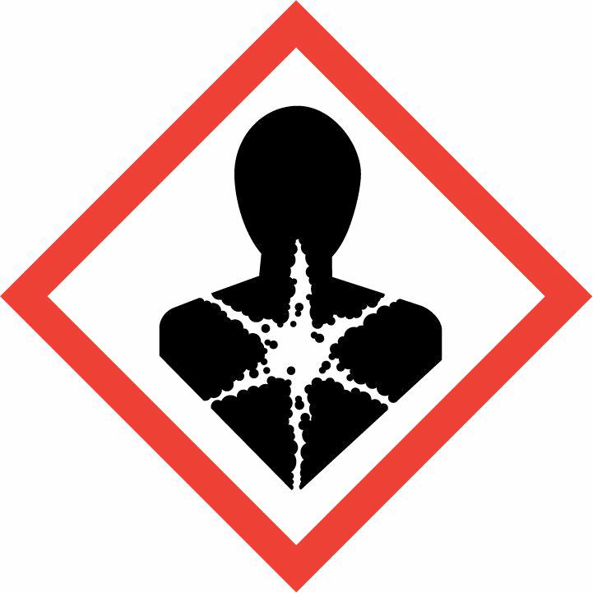

2.1. Classification of the substance or mixture

DE-ICER SPRAY

Revision
Revision date
Page 2/6

1

2.1.2. Classification - EC
1272/2008
2.2. Label elements
Hazard pictograms

Signal Word
Hazard Statement

Precautionary Statement:
Prevention

Precautionary Statement:
Response

Precautionary Statement:
Storage
Precautionary Statement:
Disposal
Flam. Liq. 3: H226; Eye Irrit. 2: H319; STOT SE 2: H371;

Warning
Flam. Liq. 3: H226 - Flammable liquid and vapour.
Eye Irrit. 2: H319 - Causes serious eye irritation.
STOT SE 2: H371 - May cause damage to organs .
P210 - Keep away from heat, hot surfaces, sparks, open flames and other ignition sources. No
smoking.
P233 - Keep container tightly closed.
P240 - Ground/bond container and receiving equipment.
P241 - Use explosion-proof electrical/ventilating/lighting// equipment.
P242 - Use only non-sparking tools.
P243 - Take precautionary measures against static discharge.
P260 - Do not breathe dust/fume/gas/mist/vapours/spray.
P264 - Wash thoroughly after handling.
P270 - Do no eat, drink or smoke when using this product.
P280 - Wear protective gloves/protective clothing/eye protection/face protection.
P303+P361+P353 - IF ON SKIN (or hair): Take off immediately all contaminated clothing. Rinse
skin with water/shower.
P305+P351+P338 - IF IN EYES: Rinse cautiously with water for several minutes. Remove contact
lenses, if present and easy to do. Continue rinsing.
P337+P313 - If eye irritation persists: Get medical advice/attention.
P370+P378 - In case of fire: Use to extinguish.
P403+P235 - Store in a well-ventilated place. Keep cool.
P405 - Store locked up.
P501 - Dispose of contents/container to

SECTION 3: Composition/information on ingredients
3.2. Mixtures
67/548/EEC / 1999/45/EC
Chemical Name Index No. CAS No. EC No.

REACH Registration
Number

Conc.
(%w/w)

Classification

M-factor.

Isopropanol (Propan-2-ol) 603-117-00-0 67-63-0 200-661-7
10 - 20% F; R11 Xi; R36 R67

Methanol

EC 1272/2008
603-001-00-X 67-56-1
200-659-6
1 - 10% F; R11 T;
R23/24/25-39/23/24/25

Chemical Name
Index No.
CAS No. EC No.
REACH Registration
Number
Conc.
(%w/w)
Classification
M-factor.

Isopropanol (Propan-2-ol)
Methanol
603-117-00-0 67-63-0
603-001-00-X 67-56-1
200-661-7
200-659-6
10 - 20% Flam. Liq. 2: H225; Eye Irrit.
2: H319; STOT SE 3: H336;
1 - 10% Flam. Liq. 2: H225; Acute
Tox. 3: H331; Acute Tox. 3:
H311; Acute Tox. 3: H301;
STOT SE 1: H370;

SECTION 4: First aid measures
4.1. Description of first aid measures

Inhalation
Move the exposed person to fresh air.

Copyright © 2015 ChemSoft Limited. All rights reserved.
Powered by
Print date 2015-11-02

4.1. Description of first aid measures

DE-ICER SPRAY

Revision
Revision date
Page 3/6

1

Eye contact
Skin contact
Ingestion
Rinse immediately with plenty of water for 15 minutes holding the eyelids open.
Wash off immediately with plenty of soap and water. Remove contaminated clothing.
DO NOT INDUCE VOMITING.

4.2. Most important symptoms and effects, both acute and delayed

Inhalation

Eye contact
Skin contact
Ingestion
Harmful by inhalation. Inhalation may cause nausea and vomiting. May cause dizziness and
headache.
May cause irritation to eyes.
May cause irritation to skin. May cause dermatitis.
Harmful by inhalation and if swallowed. Ingestion may cause nausea and vomiting. Ingestion is
irritating to the respiratory tract and may cause damage to the central nervous system.

4.3. Indication of any immediate medical attention and special treatment needed

Inhalation
Eye contact
Skin contact
Ingestion
Seek medical attention.
Seek medical attention if irritation or symptoms persist.
Seek medical attention if irritation or symptoms persist.
If swallowed, do not induce vomiting: seek medical advice immediately and show this container or
label.

SECTION 5: Firefighting measures
5.1. Extinguishing media
Use as appropriate: Carbon dioxide (CO2), Dry chemical, Foam.
5.2. Special hazards arising from the substance or mixture
. Burning produces irritating, toxic and obnoxious fumes.
5.3. Advice for firefighters
Wear suitable respiratory equipment when necessary.
SECTION 6: Accidental release measures
6.1. Personal precautions, protective equipment and emergency procedures
Ensure adequate ventilation of the working area. Eliminate all sources of ignition. Wear suitable
protective equipment.
6.2. Environmental precautions
Do not allow product to enter drains. Prevent further spillage if safe.
6.3. Methods and material for containment and cleaning up
Absorb with inert, absorbent material. Transfer to suitable, labelled containers for disposal. Clean
spillage area thoroughly with plenty of water.
SECTION 7: Handling and storage
7.1. Precautions for safe handling
Avoid contact with eyes and skin. Ensure adequate ventilation of the working area. Use explosion
proof equipment. Keep away from sources of ignition - No smoking. Adopt best Manual Handling
considerations when handling, carrying and dispensing.
7.2. Conditions for safe storage, including any incompatibilities
Keep in a cool, dry, well ventilated area. Keep containers tightly closed.
SECTION 8: Exposure controls/personal protection
8.1. Control parameters

8.1.1. Exposure Limit Values

Copyright © 2015 ChemSoft Limited. All rights reserved.

Powered by
Print date 2015-11-02

8.1.1. Exposure Limit Values
Isopropanol (Propan-2-ol)

Methanol

8.2. Exposure controls

8.2.1. Appropriate engineering
controls
8.2.2. Individual protection
measures
Eye / face protection
Skin protection -
Handprotection

DE-ICER SPRAY

WEL 8-hr limit ppm: 400
WEL 15 min limit ppm: 500
WEL 8-hr limit mg/m3 total -
inhalable dust:
WEL 8-hr limit mg/m3 total -
respirable dust:
WEL 8-hr limit ppm: 200
WEL 15 min limit ppm: 250
WEL 8-hr limit mg/m3 total -
inhalable dust:
WEL 8-hr limit mg/m3 total -
respirable dust:

Ensure adequate ventilation of the working area.

Wear chemical protective clothing.

Approved safety goggles.
Chemical resistant gloves (PVC).

Revision
Revision date

WEL 8-hr limit mg/m3: 999
WEL 15 min limit mg/m3: 1250
WEL 15 min limit mg/m3 total -
inhalable dust:
WEL 15 min limit mg/m3 total -
respirable dust:
WEL 8-hr limit mg/m3: 266
WEL 15 min limit mg/m3: 333
WEL 15 min limit mg/m3 total -
inhalable dust:
WEL 15 min limit mg/m3 total -
respirable dust:
Page 4/6

1

Respiratory protection
Self-contained breathing apparatus. Wear protective clothing.

SECTION 9: Physical and chemical properties
9.1. Information on basic physical and chemical properties
Appearance Liquid
Colour Blue
Odour Characteristic
pH ± 7
Melting point ± 848 °C
Initial boiling point ± 84.8 °C
Flash point 47 °C
Relative density ± 0.975 (H2O = 1 @ 20 °C)
Viscosity 10 mPas (Cone & Plate)
Solubility Soluble in water
SECTION 10: Stability and reactivity
10.2. Chemical stability
Stable under normal conditions.
10.3. Possibility of hazardous reactions
Oxidising agents.
10.4. Conditions to avoid
Heat, sparks and open flames.
SECTION 11: Toxicological information
11.1.4. Toxicological Information

Copyright © 2015 ChemSoft Limited. All rights reserved.

Powered by

Print date 2015-11-02

11.1.4. Toxicological Information

DE-ICER SPRAY

No data available

Revision
Revision date
Page 5/6

1
SECTION 12: Ecological information
12.1. Toxicity
No data available
SECTION 13: Disposal considerations
General information
Dispose of in compliance with all local and national regulations.
SECTION 14: Transport information
14.1. UN number
The product is not classified as dangerous for carriage.
14.2. UN proper shipping name
The product is not classified as dangerous for carriage.
14.3. Transport hazard class(es)
The product is not classified as dangerous for carriage.
14.4. Packing group
The product is not classified as dangerous for carriage.
14.5. Environmental hazards
The product is not classified as dangerous for carriage.
14.6. Special precautions for user
The product is not classified as dangerous for carriage.
14.7. Transport in bulk according to Annex II of MARPOL 73/78 and the IBC Code
The product is not classified as dangerous for carriage.
SECTION 15: Regulatory information

SECTION 16: Other information
Other information

Revision

Text of risk phrases in Section
3

Text of Hazard Statements in
Section 3
This document differs from the previous version in the following areas:.
2 - 2.1.2. Classification - EC 1272/2008.
2 - Hazard pictograms.
2 - Signal Word.
2 - Precautionary Statement: Prevention.
2 - Precautionary Statement: Response.
2 - Precautionary Statement: Storage.
2 - Precautionary Statement: Disposal.
12 - 12.1. Toxicity.
R11 - Highly flammable.
R23/24/25 - Toxic by inhalation, in contact with skin and if swallowed.
R36 - Irritating to eyes.
R39/23/24/25 - Toxic: danger of very serious irreversible effects through inhalation, in contact with
skin and if swallowed.
R67 - Vapours may cause drowsiness and dizziness.
Flam. Liq. 2: H225 - Highly flammable liquid and vapour.
Eye Irrit. 2: H319 - Causes serious eye irritation.

Copyright © 2015 ChemSoft Limited. All rights reserved.

Powered by
Print date 2015-11-02

Other information

Further information

DE-ICER SPRAY

STOT SE 3: H336 - May cause drowsiness or dizziness.
Acute Tox. 3: H301 - Toxic if swallowed.
Acute Tox. 3: H311 - Toxic in contact with skin.
Acute Tox. 3: H331 - Toxic if inhaled.
STOT SE 1: H370 - Causes damage to organs .

Revision
Revision date
Page 6/6

1

The information supplied in this Safety Data Sheet is designed only as guidance for the safe use,
storage and handling of the product. This information is correct to the best of our knowledge and
belief at the date of publication however no guarantee is made to its accuracy. This information
relates only to the specific material designated and may not be valid for such material used in
combination with any other materials or in any other process.

Copyright © 2015 ChemSoft Limited. All rights reserved.

Powered by

Print date 2015-11-02

